**Accuracy:**

* CNN

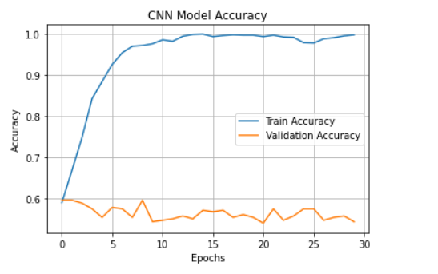

* LSTM

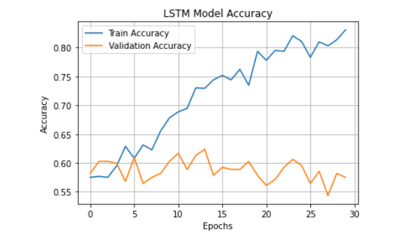

* CNN+LSTM

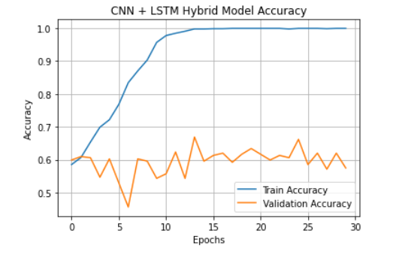

* RESNET50

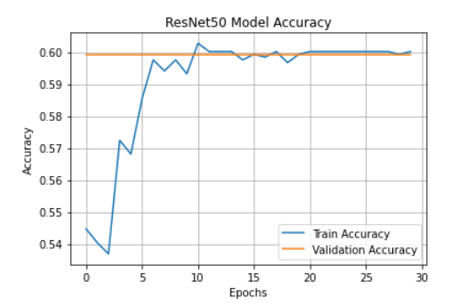

* GoogleNET

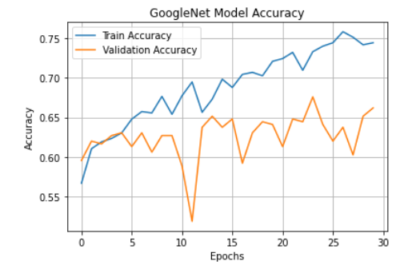

* XCEPTION

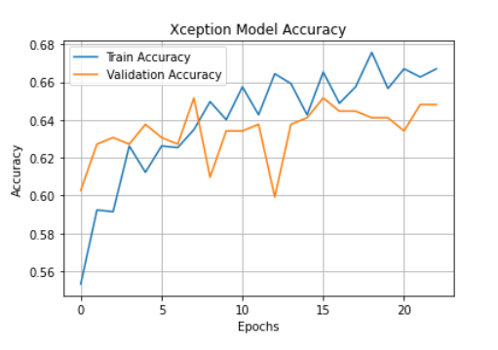

* GoogleNET + XCEPTION

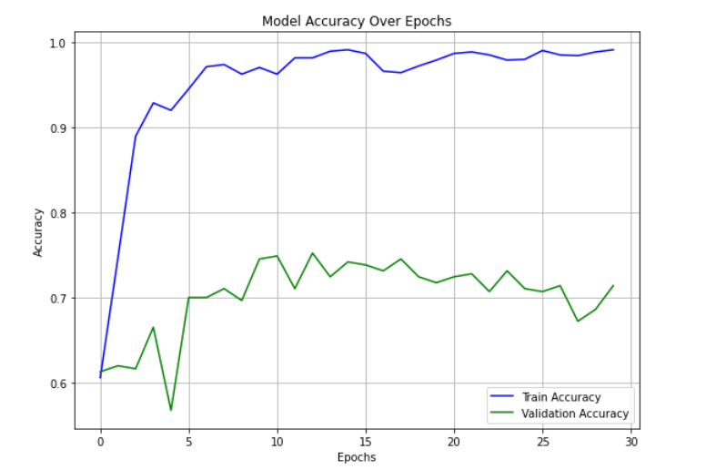

**Precision:**

* CNN



* LSTM



* CNN + LSTM



* RESNET 50



* GoogleNET



* XCEPTION



* GoogleNET + XCEPTION



**Recall:(SENSITIVITY)**

* CNN:



* LSTM



* CNN+LSTM



* RESNET 50



* GoogleNET



* Xception



* GoogleNET+ XCEPTION



**F1-Score**

* CNN



* LSTM



* CNN + LSTM



* RESNET 50



* GoogleNET



* XCEPTION



* GoogleNET + XCEPTION



**AUC-ROC(Area under the Receiver Operating Characteristic Curve)**

* CNN



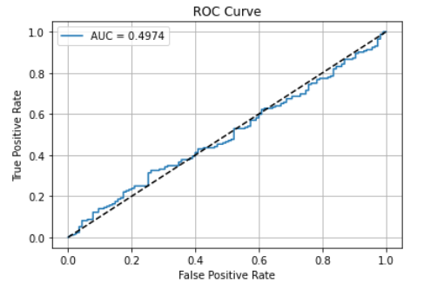

* LSTM



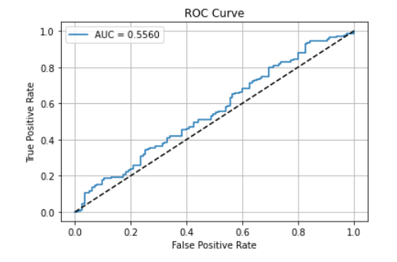

* CNN + LSTM



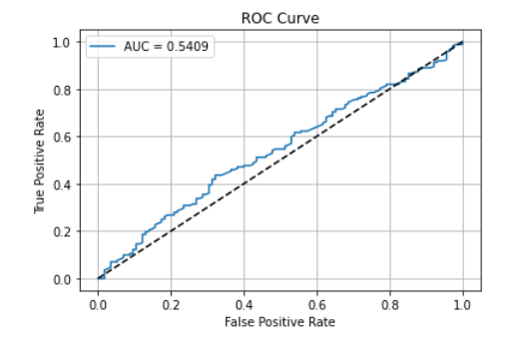

* RESNET 50



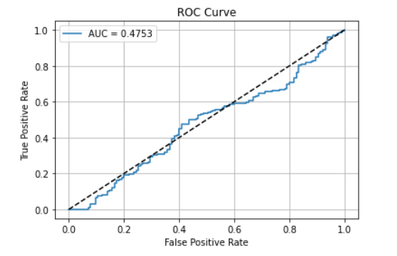

* GoogleNET



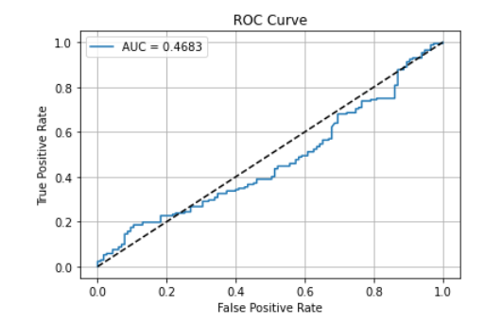

* XCEPTION



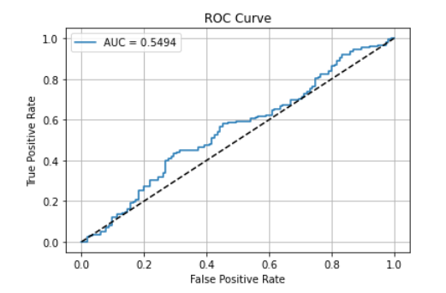

* GoogleNET + XCEPTION



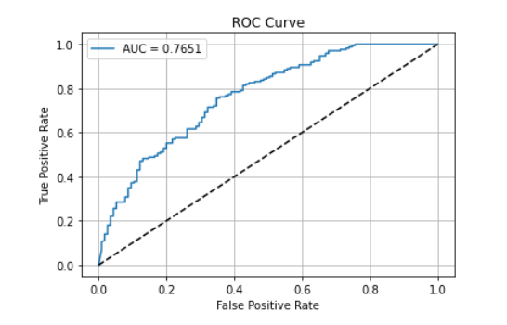

**MODEL WISE ALL DETAILS**

**CNN**

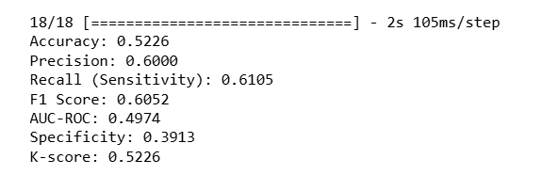

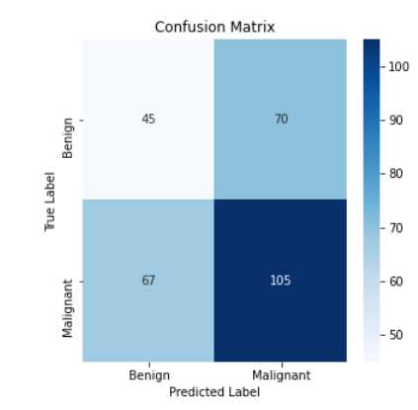

**LSTM**

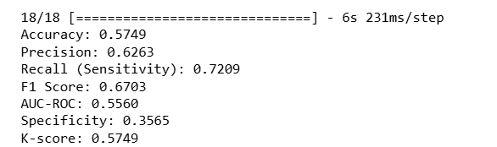

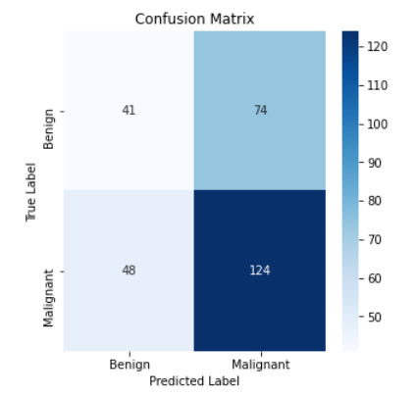

**CNN+LSTM**

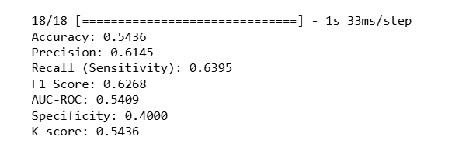

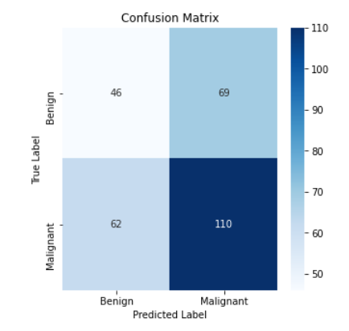

**RESNET 50**

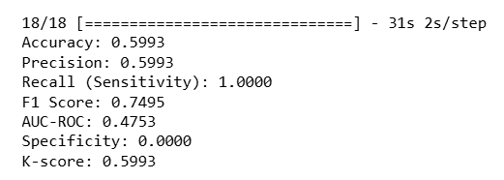

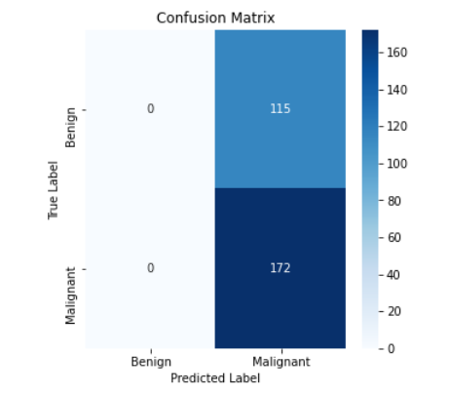

**GOOGLENET**

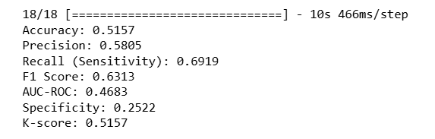

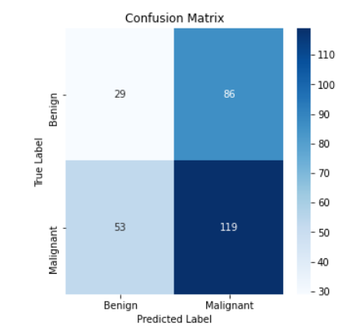

**XCEPTION**

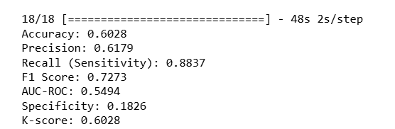

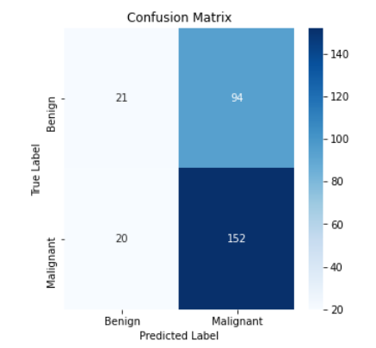

**GOOGLENET + XCEPTION**

